1. 新建Qt工程文件：

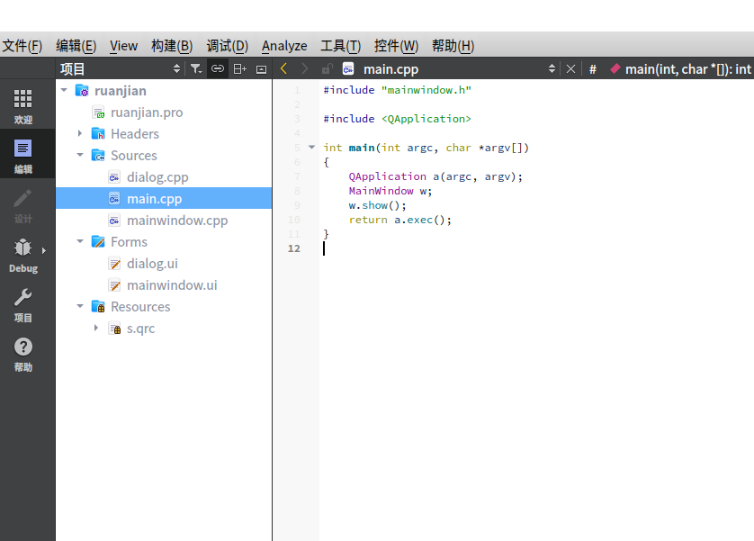

1. 设置窗口大小为400X300分辨率，主窗口中放置LineEdit输入框，标签Label，按钮Button

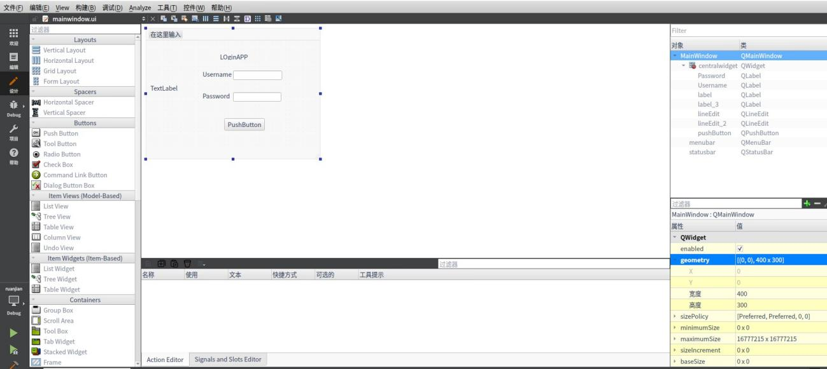

1. 在dialog中添加Label

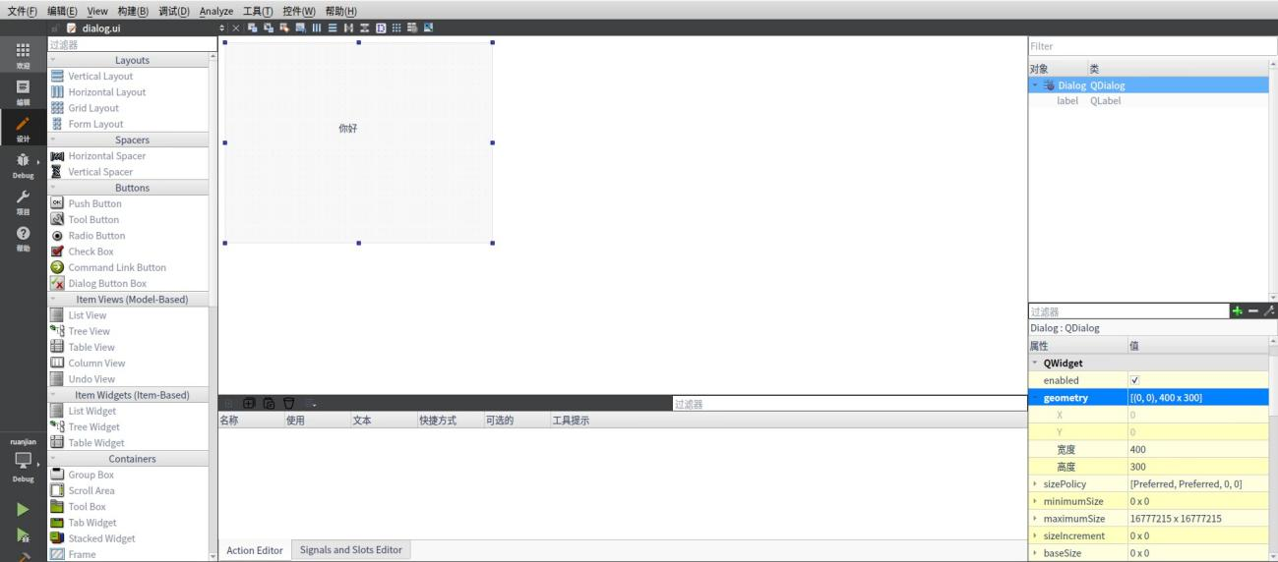

1. 添加代码

MainWindow::**MainWindow**(QWidget *parent)

: QMainWindow(parent)

, ui(new Ui::MainWindow)

{

ui->setupUi(this);

QPixmap pix(":/img/3211.png");

int w = ui->label_3->width();

int h = ui->label_3->height();

ui->label_3->setPixmap(pix.scaled(w,h,Qt::KeepAspectRatio));

}

MainWindow::~***MainWindow***()

{

delete ui;

}

void MainWindow::**on_pushButton_clicked**()

{

QString Username = ui->lineEdit->text();

QString password = ui->lineEdit_2->text();

if(Username== "Admin" && password== "123456"){

QMessageBox::information(this, "Login", "Username and password is correct");

Dialog secDeialog;

secDeialog.setModal(true);

secDeialog.*exec*();

//hide();

//Dialog = new Dialog(this);

//Dialog -> show();

}

else{

QMessageBox::warning(this,"Login", "Username and password is not correct");

}

}

1. 运行结果

